Questions for Chris:

1. Given my use of similar methods across chapters, I think I prefer to keep the data and methods chapter (chapter 2) and make more links between this chapter and others. The other chapter I sent you (chapter 3 on age and political interest) would be put right after this one. What do you think?
   1. Yes. Still helpful to talk about response rates, etc. in data and methods chapter, so keep it
   2. Highlight data and methods that are COMMON to all chapters, and also specify which ones are chapter-specific
   3. In individual chapters: "explained more fully in chapter 2"… but the main argument should be repeated
   4. Maybe ask someone who doesn't know anything about the topic to read the chapter
2. I already have two other chapters (1, the introduction, and 4, about the role of parents) which are relatively close to completion. Should I first send a first draft of one of these chapters? Which one? Or should I first send a second draft of chapters 2 and 3? Should I send these chapters back to you or to Randy and Ruth next time?
   1. Start by sending the intro to Chris Cochrane
   2. Order of chapters not that important, but chronological seems to be the most logical
   3. Make sure I have an abstract for each chapter
   4. Only contact Ruth & Randy when all chapters are done
   5. For each set of comments I've applied from both, send a detailed memo of all changes I've applied, make their life as easy as possible
3. What should I do for data I lack? For example, I do have data about Ontario and Quebec schools' average number of children which resembles those that I have (22 answers per class on average, after removing a few cases I can explain separately). Is it enough, or should I clearly state the fact that I do not know how many students were absent/did not fill the survey within each class? If they refused at the consent form level, there is no way for me to tell they were within that class because they didn't have the chance to fill their unique ID.
   1. Just say I have provincial data, that's enough
4. I am pretty sure both my nonresponse and my rejection rates are higher than other studies among children. Should I clearly state that fact, or simply say that these are low response rates?
   1. Nonresponse is higher than other studies: yes, I should document it and specify it
5. The implication of those low response rates is that the descriptive characteristics of the sample should not be seen as representative of the Canadian student population. There are no reasons to believe that the types of correlations studied here should be affected by that however, as the causal mechanisms should work similarly (not sure I should use the words "causal inference" though). Is it a good way to frame that?
   1. "A census of students does not exist"
   2. "We tried to increase the response rate in this way"
   3. "Experimentalists might want to look at patterns of influence"
   4. Maybe ask Ruth & Randy a bit of advice about how to frame that if I need it
6. What is a good enough reason to study Canada? Is it okay to say Canada would be a least-likely case for a gender gap in political interest? Despite Canada often being labelled one of the best countries for women to live in, and despite more female presence in politics, women's reported political interest is low compared to men's, and the size of the gender gap has barely moved in the past few decades. Why is it that, even in a country like Canada where conditions seem to be the best for women to be interested in politics, we still find this unchanging gender gap? We need to look at socialization.
   1. State that I am studying Canada because this country is the one I want to study while citing Alain Noël's 2014 presidential address
   2. This is why political interest in Canada is actually interested: then present what I said in the paragraph
   3. Remove the words "least-likely case"
7. Should I analyze this figure in the data and methods chapter?
   1. Yes

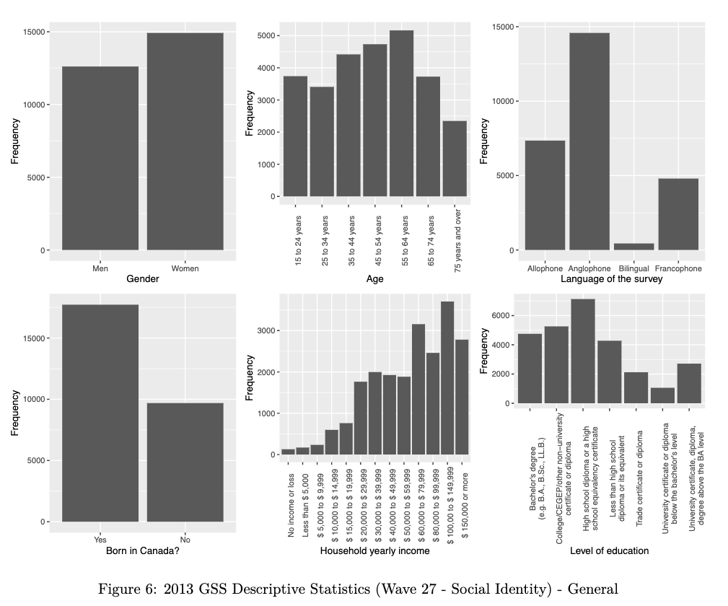

1. Should I replicate this figure with CES and WVS data? They serve as supportive data but have already been the topic of several studies and have their own survey weights which I will re-use.
   1. Modal category very different between Datagotchi and GSS, to analyze
   2. Weighting Datagotchi PES: there is no reason to believe those associations are meaningful => cite the curse of dimensionality in VAAs… or another chapter of Cliff's thesis
   3. Men and women should be in the same order on figures 5 and 6
   4. Analyze each survey's descriptive statistics
   5. Online opt-in surveys are more reliable but less valid (add studies about opt-in surveys)
2. Should I analyze time trends among adults for the evolution of internal efficacy, external efficacy, political knowledge, and other measures of political engagement? I do not have such information for children however. If yes, should I prioritize CES data, Datagotchi PES, GSS, or WVS?
   1. Still worth studying. Compare it with political interest
   2. Kenji? Gidengil et al. on internal efficacy?
   3. Political interest vs. political knowledge, which one comes first in the survey matters for how interested they will be => "Question-order effects in surveys: The case of political interest, news attention, and knowledge"
3. Graph about gender, race and immigrant status: this is not an important theme within the gender & political interest literature. I could (1) move the graph to an appendix and discuss it in a footnote, highlighting what you suggested to highlight from the graph; (2) add some literature on political interest by race/immigrant status (but would risk lacking focus, as this would most likely not concern gender); or (3) remove the graph altogether (but could be criticized for non-intersectional gender work).
   1. Add the graph about intersectionalities and use some work about intersectionality. Add it towards the end of the chapter, cite one or two sources
4. Blocs for control variables: should I add subsections for blocs, with still one line per variable (and have even longer tables)? Or should I aggregate variables into a kind of scale? Generally I should only keep variables which have both been related to the IV and DV in previous studies (or could reasonably be thought to be)?
   1. Garbage can model: a bunch of controls, unexplained, bad. Kitchen sink model: association between two variables holds even after adding a bunch of variables. Add this table with controls in the appendix.
   2. Adding bunches of variables one after the other, and then each table in the appendix
5. Discussion of the models: in data and methods chapter, sectoral chapters, or both?
   1. Yes, in data and methods chapter, to be repeated
6. Should I analyze qualitatively the survey question about open-ended definitions of political interest? Or quantitatively? I could compare this to the definition of politics in chapter 1: "Politics, in its broadest sense, is the activity through which people make, preserve and amend the general rules under which they live. Politics is inextricably linked to the phenomena of conflict and cooperation. On the one hand, the existence of rival opinions, different wants, competing needs and opposing interests guarantees disagreement about the rules under which people live. On the other hand, people recognize that, in order to influence these rules or ensure their enforcement, they must work with others" (Heywood, 2007). I could have a very quantitative analysis such as "mention of rules = +1, mention of conflict = +1, etc." or just analyze the general level of agreement with this and some other definitions within the literature.
   1. Just do a qualitative analysis, + a little score with number of answers that mention this or that (+ patterns for men vs. women)
   2. Guidelines for how to code them: I could send them to Chris => someone else could code. That would be a better practice than me coding by myself